**NATIONAL INSTITUTE OF TECHNOLOGY- TRICHY**

GROUP 61 – ECE A



**ENERGY AND ENVIRONMENT PROJECT**

**SOLAR TRACKER**

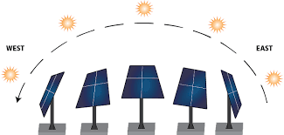

**DONE BY:**

* ARVINDAKSHA. G
* ARAVINDAN. E
* G. SRIVATHSA
* K. GIRISH
* PREMKUMAR. N

**TEAM MEMBERS**

1. **Arvindaksha.G**

Department: Electronics and Communication Engineering

Section-A

Roll number: 108119017

1. **Aravindan.E**

Department: Electronics and Communication Engineering

Section-A

Roll number: 108119035

1. **G. Srivathsa**

Department: Electronics and Communication Engineering

Section-A

Roll number: 108119039

1. **K. Girish**

Department: Electronics and Communication Engineering

Section-A

Roll number: 108119053

1. **Premkumar.N**

Department: Electronics and Communication Engineering

Section-A

Roll number: 108119085

**ACKNOWLEDGEMENTS**

#### We sincerely thank our professors Mr. G. Suriya Narayanan, Dr. Sankaran Krishnamoorthy, Dr. Amol B. Mande, Dr. Nivedhini Iswarya C for their valuable guidance and help throughout the semester and inspiring us to take up this huge project and making it a success.

**RESEARCH AIM**

To build a single axis solar tracker that will always follow the movement of the sun throughout the day and produce a better power output.

**INTRODUCTION**

Solar Tracker is a device which follows the movement of the sun as its position changes relative to earth from the east to the west every day. The angle of incidence of light rays on the solar tracker decreases to a great extent by using a solar tracker. So the solar tracker collects the sun's energy with maximum efficiency when the optical axis is aligned with incident solar radiation. The solar energy incident on the solar panel increases. This in turn improves the efficiency and amplifies the energy output.

It must also be designed to withstand harsh weather conditions and it must also have an estimated useful life equal to or similar to that of the PV module.

 A solar tracking system is composed of three well-differentiated components: the mechanism, the driving motors, and the tracking controller.

Taking into account the type of mechanism, solar tracking systems can be classified into single axis trackers or [two-axis trackers](https://www.sciencedirect.com/topics/engineering/two-axis-tracker).

**Single axis trackers:**

Because solar tracking implies [moving parts](https://www.sciencedirect.com/topics/engineering/moving-part) and control systems that tend to be expensive, [single-axis tracking](https://www.sciencedirect.com/topics/engineering/single-axis-tracking) systems seem to be the best solution for small PV power plants. A single-axis solar tracking system uses a tilted PV panel mount and one electric motor to move the panel on an approximate trajectory relative to the Sun's position. The [rotation axis](https://www.sciencedirect.com/topics/engineering/rotation-axis) can be horizontal, vertical, or oblique. A one-axis tracker has both the rotation axis (unit vector e) and the collector plane (unit vector normal to the collector plane). The angle between these two unit vectors is usually kept constant in this type of tracker.

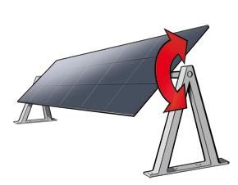

##### Two-Axis Trackers:

This type of solar trackers enables the PV panel to move in both axes, thus aligning the solar panel directly towards the sun with maximum accuracy. Using two-axis trackers, maximum energy collection can be achieved because, due to its total freedom of movement (north–south and east–west), the tracker can face the sun's rays throughout the day.

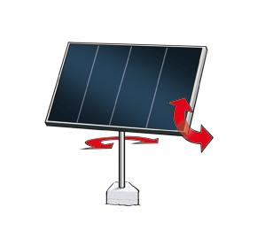 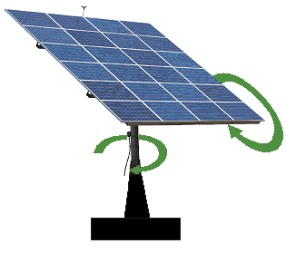

Depending on their control, solar trackers can be classified into solar tracking systems that orient the PV panels based on previously computed sun trajectories (open-loop control) and solar trackers that used a [solar radiation](https://www.sciencedirect.com/topics/engineering/solar-radiation) sensor to control the orientation of the system (closed-loop control).

##### Closed Loop Controllers

These controllers are based on the use of direct solar sensors to detect the position of the Sun. For this purpose, the sensors are composed of photosensitive elements mounted on the panel.

**Open Loop Controllers**

This control technique also uses a [microprocessor](https://www.sciencedirect.com/topics/engineering/microprocessor-chips), but it does not need any sensor to determine the position of the Sun. The movement of the Sun can be predicted using astronomic relationships, which are programmed in the microprocessor so that the microprocessor itself can calculate the Sun's position at any time.

**METHODOLOGY**

**MATERIALS/COMPONENTS REQUIRED:**

1. 1 x Arduino Uno microcontroller
2. 2 x light dependent resistors(LDR)
3. 2 x 4.7K ohm resistors
4. 1 x Servo motor(with attachments)
5. 1 x Breadboard
6. Jumper wires
7. 5V wall adapter
8. Solar panel

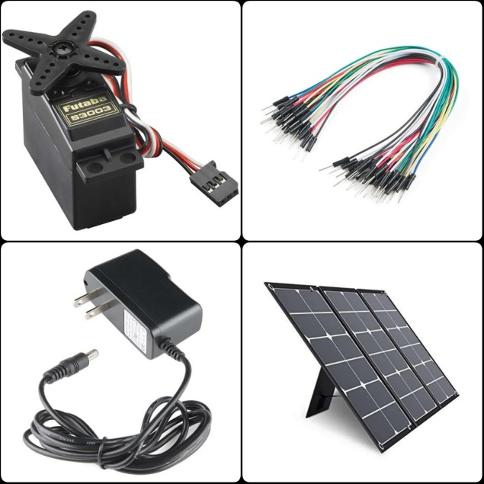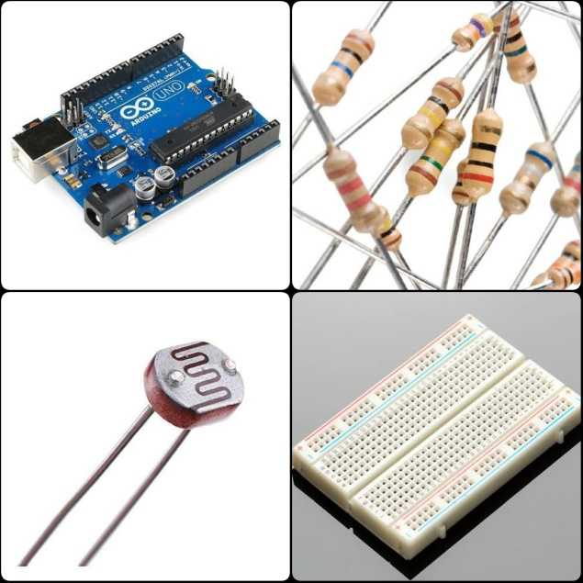

**WORKING PRINCIPLE:**

This project is a simplified version of a solar tracker. It uses the Arduino microcontroller, Light dependent resistors and a servo to orient the solar panel in the direction of maximum sunlight (east, west or directly vertical).

This solar tracker control system is designed to take light measurements from the east and west (left and right) side of the solar panel and determine which way to move the panel to point it directly at the source of the light. A servo is used to actuate the panel tracker; these are available in a broad range of sizes and can be scaled according to your panel size. Although this tracker is single axis, the two sensors and servo can simply be duplicated to provide dual axis control.

Shown below is the circuit diagram of our project.

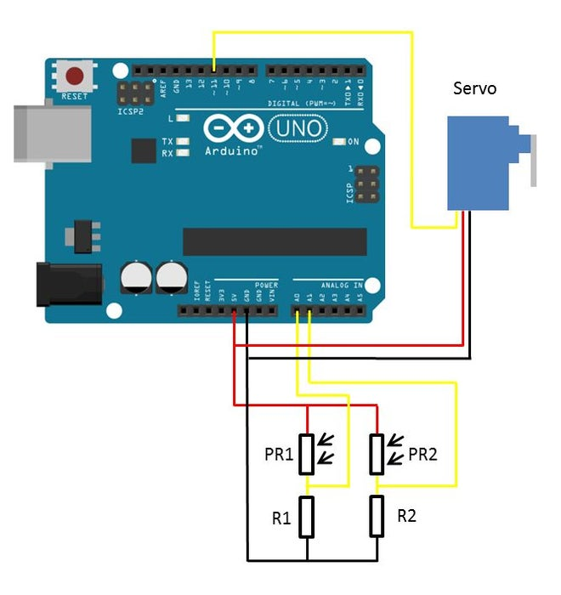

Given below is the code for our project:

**CODE:**

#include <Servo.h> //To include Servo library

Servo tracker; // create servo object to control a servo

int eastLDRPin = 0; //Assign analogue pins

int westLDRPin = 1;

int eastLDR = 0; //Create variables for the east and west sensor values

int westLDR = 0;

int error = 0;

int calibration = 35; //Calibration offset to set error to zero when both sensors receive an equal amount of light

int trackerPos = 90; //Create a variable to store the servo position

void setup()

{

tracker.attach(11); // attaches the servo on pin 11 to the servo object

tracker.write(90);

Serial.begin(9600);

}

void loop()

{

eastLDR = calibration + analogRead(eastLDRPin); //Read the value of each of the east and west sensors

westLDR = analogRead(westLDRPin);

Serial.println(analogRead(A0));

Serial.println(analogRead(A1));

if(eastLDR<50 && westLDR<50) //Check if both sensors detect very little light, night time

{

while(trackerPos<=140) //Move the tracker all the way back to face east for sunrise

{

trackerPos++;

tracker.write(trackerPos);

delay(100);

}

}

error = eastLDR - westLDR; //Determine the difference between the two sensors.

if(error>30) //If the error is positive and greater than 15 then move the tracker in the east direction

{

if(trackerPos<=140) //Check that the tracker is not at the end of its limit in the east direction

{

trackerPos++;

tracker.write(trackerPos); //Move the tracker to the east

}

}

else if(error<-30) //If the error is negative and less than -15 then move the tracker in the west direction

{

if(trackerPos>40) //Check that the tracker is not at the end of its limit in the west direction

{

trackerPos--;

tracker.write(trackerPos);

//Move the tracker to the west

}

}

if(error<30&&error>-30&&eastLDR>50&&westLDR>50) //If equal light is falling on the sensors

{

tracker.write(90);

}

delay(100);

}

The code essentially measures the light intensity from both photo resistors; it then compares the two to see which is receiving more light. If the difference is greater than a small threshold then the Arduino tells the servo to move in that direction to direct the panel towards the light source. If the light falls below a certain level on both sensors then it is detected as night time and the panel is moved to face east again for sunrise. Comments are given at the end of each line as an explanation.

**PROCEDURE**:

1. Connect the circuit as per the circuit diagram shown above.
2. Because the servo motor used cannot be powered by the Arduino, the 5V wall adapter is used. It provides a voltage of 5V to the servo. The servo and the Arduino are joined by a common ground connection.
3. The signal pin of the Servo motor is attached to pin 11 of the Arduino. The LDR’s are connected to analog pins A0 and A1 of the Arduino.
4. Pull down resistors of value 4.7K ohms are used to avoid floating inputs.
5. Calibrate the servo to an angle of 90 degrees initially.
6. Fix the solar panel to the servo attachment. Here, a thermocol piece is used instead of a solar panel.
7. Upload the code to the Arduino using USB.
8. Make sure that the wires do not obstruct the light falling on the LDR’s.
9. Review the connections before proceeding.

**WORKING:**

Firstly, orient the LDR’s and the panel in the east-west direction. Make the room dark to simulate night time. The panel will shift towards east direction for the nest day’s sunrise. Now, shine light one the west LDR and we can see that the panel moves towards west. Now, shine light on the east LDR and we can see that the panel moves towards the east.

**OUR CIRCUIT:**

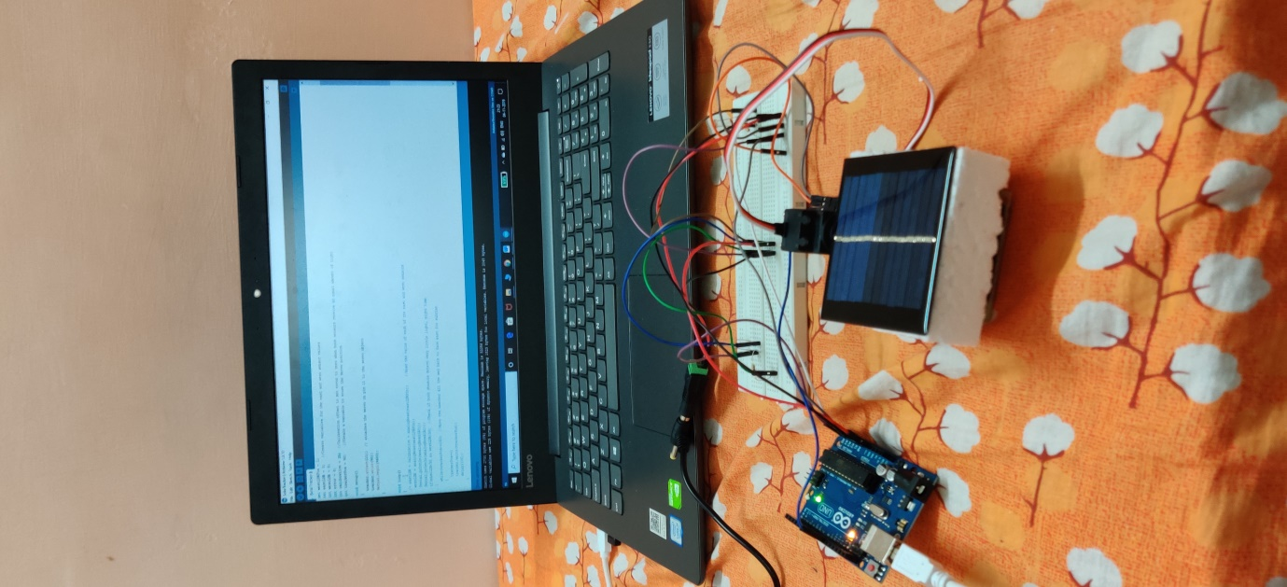

More and more people are realizing the amazing benefits of solar energy and looking at making solar energy part of their homes. As more people install solar panels, there are a lot of questions about using solar panel tracking to get the most out of this investment in solar power.

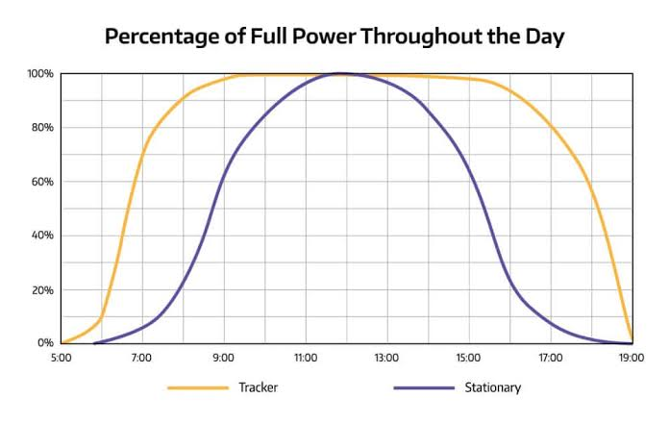

The main draw of solar panels that follow the sun is that they are significantly more efficient than fixed solar panels. A dual-axis solar panel tracker may be as much as 40% more efficient than a fixed solar panel. And even single-axis trackers can offer a 25% or more boost to your solar power generation.

**BENEFICIARIES AND SOME STATISTICS**

**General advantages**

* Trackers generate more electricity than their stationary counterparts due to increased direct exposure to solar rays. This increase can be as much as 10 to 25% depending on the geographic location of the [tracking system](http://solarflexrack.com/wp-content/uploads/2014/06/SFR-TDP-Tracker-Flier-Rev-1.pdf).
* There are many different kinds of solar trackers, such as [single-axis](http://solarflexrack.com/products/tracker/) and [dual-axis](https://www.solarpowerworldonline.com/2017/09/dual-axis-solar-tracker/) trackers, all of which can be the perfect fit for a unique jobsite. Installation size, local weather, degree of latitude and electrical requirements are all important considerations that can influence the type of solar tracker best suited for a specific solar installation.
* Solar trackers generate more electricity in roughly the same amount of space needed for fixed-tilt systems, making them ideal for optimizing land usage.
* In certain states, some utilities offer Time of Use (TOU) rate plans for solar power, which means the utility will purchase the power generated during the peak time of the day at a higher rate. In this case, it is beneficial to generate a greater amount of electricity during these peak times of the day. Using a tracking system helps maximize the energy gains during these peak time periods.
* Advancements in technology and reliability in electronics and mechanics have drastically reduced long-term maintenance concerns for tracking systems.

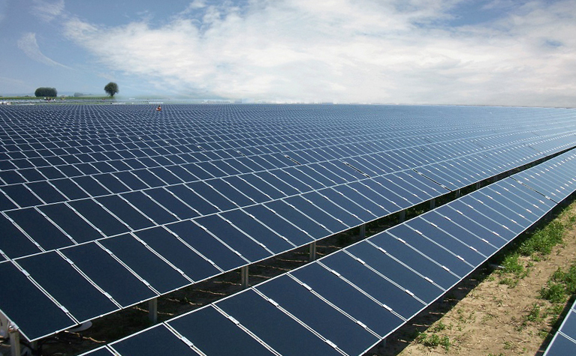

**Beneficiaries in various countries across the world**

London, UK [Renewable Energy World Magazine] The use of tracking technology allowing solar modules to follow the course of the sun (and so optimize the incident angle of sunlight on their surface) can increase electricity production by around a third, and some claim by as much as 40% in some regions, compared with modules at a fixed angle.

The development of feed-in tariffs and other similar support measures that reward PV producers per kilowatt hour delivered to the grid, has stimulated this growing interest in maximizing output from a given area, along with the relatively high prices for silicon-based PV modules that have been witnessed over recent years.

With key economic drivers dictating that developers maximize system output, interest in tracking technology has soared.

Indeed, Paula Mints, principal PV analyst at Navigant Consulting, has reportedly forecast that between 2009 and 2012, tracking systems will be used in at least 85% of PV installations above 1 MW.

In Spain, for example, which has seen its solar market surge in response to government policy initiatives, tracker projects went from making up an insignificant part of the market in 2006 to perhaps 25%–30% of new projects in 2008, estimates Maria Lahuerta Antoune, international marketing manager for ADES – a tracker manufacturer based in Zaragoza, Spain. ADES reportedly saw a 40% increase in production in 2008 as the country installed a total PV capacity estimated at around 2.5 GW.

As with other technologies, increasing the complexity inevitably introduces additional possibilities for malfunction and failure.

However, while tracker technology may be perceived as inherently more risky than extremely simple fixed angle systems, growing market exposure is boosting developers’ confidence in the reliability of tracking technology.

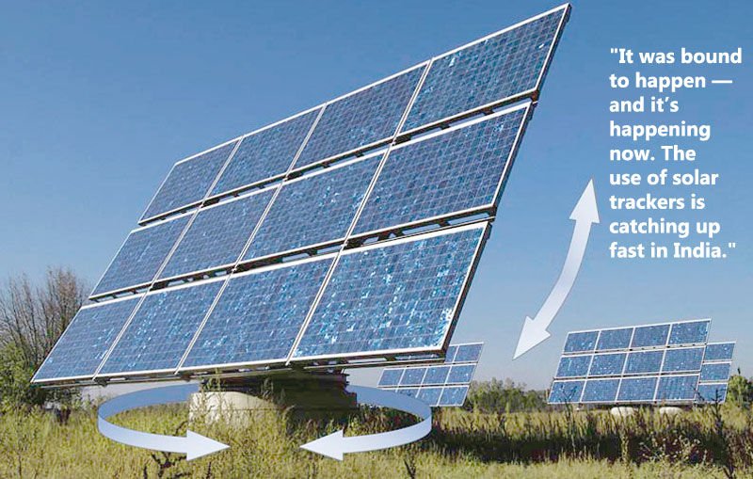

The increasing demand for green energy has witnessed many countries enters into the solar market and therefore using solar trackers for electricity generation, expanding the global solar tracker market size. Also, the subsidies provided by various governments to fulfil their ambitious green energy targets and reduce carbon footprints have acted as market drivers for the global market. The solar industry has been seen as a significant opportunity by the investor, and therefore, investments in the solar tracker industry have increased over the years.

Over the last decade, North America and Europe have dominated the global market. The major countries in the market are the USA, Italy, Spain, and Germany. In recent years, the other regions have exhibited healthy growth in the market, namely, Latin America and the Asia Pacific.

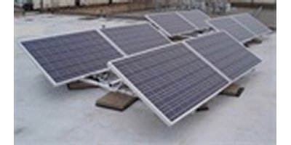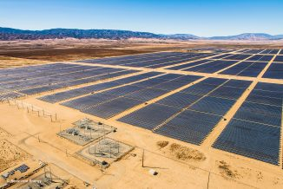

**SOLAR TRACKER IN USA SOLAR TRACKER IN DESERTS**

**Global contribution to Energy production and market**

The multi-billion dollar global demand for solar trackers is red hot, and expected to continue to glow red for at least the next five years, according to the latest market forecast.

The global single-axis solar photovoltaic tracker market is expected to show a cumulative average growth rate of close to 28% during the period 2019-2023, according to [a December research report](https://www.businesswire.com/news/home/20181227005304/en/Global-Single-Axis-Solar-PV-Tracker-Market) by Technavio.

This increase in sales is expected to drive the market value up to $27 billion by 2024, according to a June analysis by Global Market Insights.

As stunning as this expansion sounds, the growth momentum of the market is expected to decelerate this year due to a decline in the year-over-year growth.

That is because the 2017 market grew a whopping 32% in 2017, representing 14.5 gigawatts of solar capacity, according to a February report by GTM Research.

Regardless of the exact percentage of the expansion, the great news is that solar energy is expanding at light speed globally, as more governments realize that solar energy is less expensive than fossil fuel alternatives to power the national grid.

Indeed, while the United States is expected to continue to be the strongest country market for solar trackers over the mid-term, China, Brazil, Mexico, and the UAE are also driving up domestic capacity quickly.

Technavio reckons that the Americas led the market in 2018 with more than 47% of the market share, followed by the APAC and EMEA regions, respectively. “Mexico and Brazil are two of the fastest-growing solar markets in the world, each accounting for over 1.5 gigawatts of tracker shipments in 2017,” said Scott Moskowitz, senior analyst at GTM Research and author of the study, said at the time.

“The U.S. utility-scale market was significantly stunted last year due to tariff uncertainty, so it took a back seat to Latin America,” he said, referring to the uncertainty surrounding the U.S. tax credit for solar installations.

These yield boosts are accompanied by modestly increased costs over fixed-tilt that still make the cost/benefit analysis a no-brainer.

Lazard’s 12th Levelled Cost of Energy comparison, as of November, showed that a single-axis utility-scale solar system costs around $45 per megawatt-hour, compared with $170/MWh for fixed-tilt commercial or industrial installations.

Lazard adds in all costs from capital to operation and maintenance to reach these LCOE calculations.

These yield boosts are accompanied by modestly increased costs over fixed-tilt that still make the cost/benefit analysis a no-brainer.

Lazard’s 12th Levelized Cost of Energy comparison, as of November, showed that a single-axis utility-scale solar system costs around $45 per megawatt-hour, compared with $170/MWh for fixed-tilt commercial or industrial installations. Lazard adds in all costs from capital to operation and maintenance to reach these LCOE calculations.

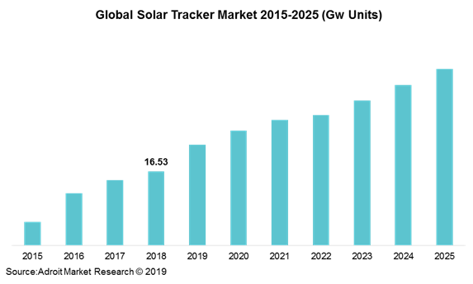

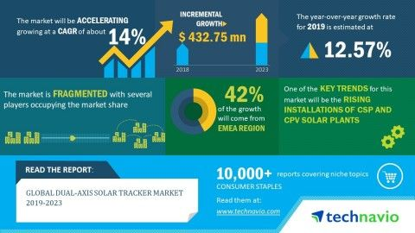

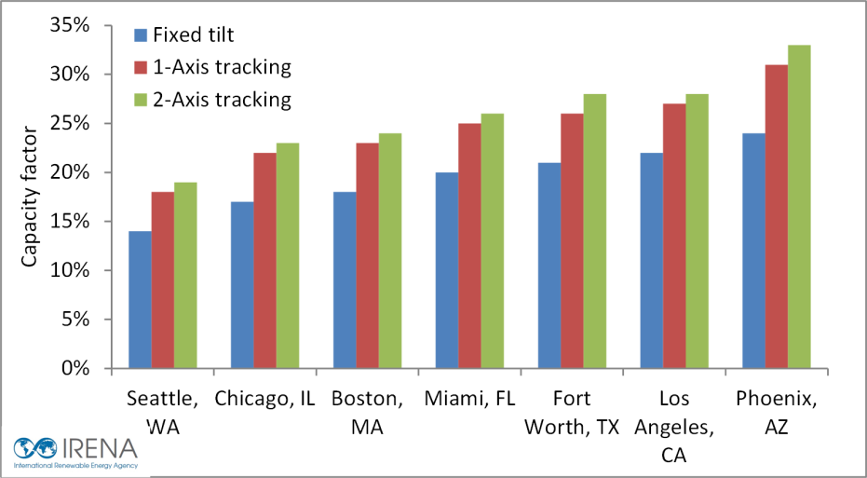

**EXPECTED OUTCOME**

The experimental design of this project included the following steps:

(i) The novel solar tracking generation system was measured, and its performance was analysed.

(ii) The system configuration and operation principles were evaluated.

(iii) The performance of this power generation system and the solar irradiance were measured according to local time and conditions

(iv)The main factors affecting system performance were analysed.

(v) The amount of power generated by the solar tracking system was compared with the power generated by fixed solar panels.

The experimental results indicated that compared to the power generated by fixed solar panels, the solar tracking system generated about 20% to 25% more power.

Solar trackers offer the greatest value proposition in high latitude locations due to the yearly movements of the sun.

In addition, the performance of this novel power generating system was found to be closely associated with solar irradiance. Therefore, the solar tracking system provides a new approach to power generation.

* On a typical clear and sunny day, fixed panel has maximum output only during 11:00 AM to 3:00 PM. Automatic tracking system panel is 60% efficient at 7:00 AM, 95% efficient at 12 noon, and 83.7% efficient at 5:00 PM.

The average power of the automatic solar tracking system leads ahead by 17.45% to that of fixed panel on a typical clear and sunny day.

• On a partly cloudy day, fixed panel has maximum output only during 11:00 AM to 2:00 PM. Maximum power output of the fixed panel is only 62.7% of the rated power output.

• Fixed and automatic tracking have less power output than the other days.

• From the above conclusions a final conclusion could be made that in any environmental condition the automatic solar tracking system is a way much better implementation than the fixed panel.

.

**Following additions can be made to the prototype to maximize the power conversion:**

* By connecting the solar panels in an array more energy can be extracted
* Using aluminium type of material for the assembly set up the weight upon the motors can be reduced which will automatically reduce the power consumption of the system.
* With the monocrystalline PV panel in use the efficiency of the project can be increased.
* Even from the quality of solar panel the power output can be increased, its detailed as follows.

**Grade A, B, C, D**

When purchasing name brand solar panels, it should be perfect grade A cells in order to get power output

* Grade A: No imperfections – output = 100%
* Grade B: Cosmetic imperfections – output > 90%
* Grade C: Contains chips and/or micro-cracks – output = 75 to 90%
* Grade D: Fallout – output = 25% to 75%

**BIBLIOGRAPHY**

**Methodology:**

<https://www.google.com/>

<https://www.instructables.com/id/Arduino-Solar-Tracker-Single-or-Dual-Axis/>

<https://en.wikipedia.org/wiki/Solar_tracker>

<https://www.sciencedirect.com/topics/engineering/solar-tracking-system>

<http://www.lauritzen.biz/products/pumping/pvvfd/index.html>

**Beneficiaries:**

<https://www.solarpowerworldonline.com/2016/05/advantages-disadvantages-solar-tracker-system/>

<https://www.renewableenergyworld.com/2009/06/01/solar-trackers-facing-the-sun/>

<https://cleantechnica.com/2018/12/27/the-solar-tracker-global-growth-rate-is-stunning/>

<https://www.fortunebusinessinsights.com/industry-reports/solar-tracker-market-100448>

**CONTRIBUTIONS OF TEAM MEMBERS**

**GROUP 61**

1. **Arvindaksha. G**

**Roll No- 108119017**

Designing the A3 poster

Report- Front page design and list of team members

Assembling the circuit

1. **Aravindan. E**

**Roll No- 108119035**

Report- Expected outcome

Compiling the report

Assembling the circuit

1. **G. Srivathsa**

**Roll No- 108119039**

Report- Research aim and Introduction

Compiling the report

Assembling the circuit

1. **K. Girish**

**Roll No-108119053**

Assembling the circuit

Report- Methodology

Programming the circuit

1. **Premkumar. N**

**Roll no- 108119085**

Designing the A3 poster

Report- Beneficiaries and Bibliography

Assembling the circuit